***FOC Tip of the Week***

* If a pre-cert company tells you at verification that the Eval is included, you must ask if **treatment** is included as well or **only** the evaluation? Some only authorize “Evaluation”, not a treatment session, very important to clarify so that our services are covered
* If you see a 12:00am encounter on your Visits without Charges report, this should be a red flag for the FOC. Open the case id and verify the DOS is accurate and that the patient was there on that date. If not, verify any encounter charge under the “Treatments/DME” tab – if there are no charges for this specific DOS, click on the “Medical Records/Retail Supply” tab. If this encounter sits in there and there are $0.00 associated across the entire line, verify if you or anyone else in your clinic sold a retail supply. If not, “trash can” this encounter as it’s not valid. If there is $ associated to it, leave it as is and submit an Agile ticket to check for accuracy.
* Avoid having your patient wait for you to make several weeks-worth of appts after their Eval. Ask your patient their time preference; morning or afternoon, confirm the next appt with them and let them be on their way informing them that you will have a schedule made for them to review when they come in for their next appt
* Always ask your patients as they leave therapy “When do we see you next?” this will tell you if they are aware of their schedule or if we may need to provide them with a new one
* Self-Pay Rate – please be discreet when offering this to our patients. This discounted rate should only be offered to a patient if they are making a specific inquiry, maxed benefits, etc. We should not be offering this discounted rate at any other time. Please use best judgment and when in doubt, reach out to your CD and/or Team Lead.

* When Interpreter Services are needed for our patient’s, we should be utilizing our new service - Cyracom Interpreter Services. This new service is expected to enhance the patient experience as well as allow us to manage the costs of interpreter services. Reach out to your Team Leads for direction on using this new service

* Ask your new patient “Have you contacted your insurance to verify your benefits?” if the answer is no, please ask them again. We want to explain to the patient that it is in their best interest to understand their benefits to ensure what we are being told at time of verification is accurate. We want to prevent any surprise balances being dropped to the patient as well as providing superior customer service
* We as FOCs need to ensure that we have a precert/authorization IN HAND for those patients whose insurance requires one, prior to treating a patient. If we treat a patient without this in hand, we MUST be sure that we can obtain a retro-authorization to get the services rendered, covered. If you CANNOT obtain a retro authorization, we must inform our CD and reschedule the patient. All communications of a patients precert/auth needs must be communicated with both the patient as well as the clinician.
* Remember to keep patient’s informed when balances drop as their responsibility and ask for payment. If a patient does not pay in full we need to be documenting in the “Notes” section of the home page, within the patient’s chart as to why we did not collect or what the arrangement is that you have discussed and was agreed upon for them to pay.
* **Patients arriving late or no-showing their appointments** – it is expected that the FOC will contact the patient within 15 minutes of their scheduled appointment time. Display genuine concern to the patients that all is ok then to confirm they are still coming to that appointment. If the patient cannot make that appointment, we must be attempting to reschedule it to another day/time that same week.
* The Self Pay form that all clinics should be using is located on our Intranet à Forms àFront Office à All Practices à Patient Self Pay Program – a link has been attached below for your reference  
    
  <https://agilityhealth.sharepoint.com/:b:/s/AlliancePTPIntranetForms/EWzu-ItY4eNOpsNxee9HKBwBdz0lhXdxB9EYTyVmt3TAFA?e=1ofShc>
* **Email Collection/Strive** – remember to ask every patient for a working email. The reasons that benefit the patient are it allows us to send them important tips and information pertaining to their diagnosis as well as exercises. It also allows Strive to send them a “Welcome Email” which includes a link within it to access the paperwork they should complete prior to coming in for their evaluation as well as directions to the clinic and information about their therapist. By doing this you do not have to send a separate email to the patient including their New Patient Paperwork.
* **Medicare Patients & Home Health** – whenever a patient presents with a Medicare insurance, **the FOC must ask those patients if they are currently enrolled in Home Health**. This can be physical therapy, or a variance of skilled nursing done within their home (bp checks, for example). If the answer is yes, we must explain to the patient that they must be discharged from Home Health prior to attending outpatient physical therapy. An oasis/discharge will be completed by the home health provider indicating the date of discharge from Home Health. If the patient is unsure, ask them for the name of the provider or a phone number and you will gladly follow up with them yourself. Explain to the patient that Medicare will not reimburse for a claim outside of the home if they are currently enrolled in home health – they must be discharged first. Medicare will not pay for both services.
* **New Patient Paperwork (Forms)** – to reduce the amount of paperwork a “returning” patient needs to complete, you can save time by presenting the patient with the following:

* + **Patient Profile Sheet (Agile)** – if all information is identical to what’s listed, you may print this out and have the patient sign & date, scan to the case. This needs to be updated yearly
  + **Medical History Form** – if all items are exactly the same from a previous Medical History form, the patient can review the previous one completed, initial and date it so we have something on file stating it was reviewed. Scan to the case. Any changes to this form, the patient must complete a new Med Hx form. This needs to be updated yearly
  + **Consent to Treat** – all patients **must** sign a new Consent to Tx at the beginning of every new episode of care
  + **HIPAA** – needs to be signed & updated yearly
  + **Additional forms such as pain scales**, MCR Secondary payer, etc., completed as needed

* **Changing Insurance Coverage** – need to make sure you end date the previous insurance, save and close. Create a new insurance with the effective date of the new insurance start date through end date 12/31/20xx. Do not change the insurance as claims may not be paid from the previous insurance carrier, we must end date that coverage.
* **New Patient Paperwork** must be scanned into the patient’s case within 24 hours of Eval. This includes the new patient packet of paperwork; Face sheet, Consent to Treat, HIPAA, Medical History; photo id, insurance card(s), Referral (Script for Therapy). In addition, you may have pain scales, questionnaires, etc. that must also be scanned within this timeframe.

* **Credit Cards on File** can never be saved or stored within Agile or anywhere within the clinic. This includes locked storage boxes, cabinets, etc. If a patient wants to have their credit card stored in order to automatically pay their copay payments, we must contact Revenue Cycle who can arrange to have their copays paid on a weekly or monthly basis (Waystar activated).
* **Onset Dates** **& Accident Box** (Agile) must be obtained & box checked within Agile when onboarding a new patient that is involved in an accident (Work Comp, Auto/MVA). We need to avoid claims rejecting due to missing this important detail. Ask the patient what the date of the accident was and confirm with the NCM/ADJ (Nurse Case Manager or Adjustor, if Work Comp) when obtaining claims address and authorization. If an Auto accident, the date of injury/onset date will be confirmed by CIV with the Claims Representative. If the date is different than what the patient provides, always use the date the NCM and/or Adjustor as well as Claims Representative has provided.
* **Financial Summary** – this summary is within every patient’s account and must be looked at and discussed with the patient if a balance is their responsibility. If a patient has a balance, it is the FOCs obligation to discuss these with the patient, explaining why they have a balance (missed copays, deductibles not being met, coinsurances) and collecting on it. Clear and consistent communication must be documented within the Home Page (Notes section) of the patient’s chart when payment is not received in full and what arrangements have been made.
* **Patient Collection Calls** – if a patient calls on their account that has been placed in Collection, the patient needs to contact the Collection Agency phone number on their collection statement. Our Billing department cannot assist on these balances as they are now in the hands of collections where they are being monitored, collected on and trac
* **Creating & Reopening cases** – we can reopen a case if it is for the same body part and the patient was previously treated within 30 days. If the patient does not meet the criteria, a new case needs to be created. Some examples are displayed below:
  + Same patient returning post-op, same doctor, same diagnosis: reopen SAME case if within 30 days
  + Same patient returning, same doctor, different diagnosis: NEW case
  + Same patient returning, different doctor, same diagnosis: NEW case

* **Creating a New Case for an existing patient** = If a patient has multiple cases created and the insurance coverage is the ***same***, we still need to make sure that you scan all existing insurance card(s), ID, facesheet/completed patient paperwork into the new case. This information doesn’t automatically transfer into the new case as it will have to be manually added to the new case.
* **Managing Cancels/No Shows** - If a patient cancels with an unforeseen reason that may indicate more than 1 future cancel that current week, click on that patient’s next scheduled appointment that week and put a note on that appointment stating “Call to Confirm” along with an exclamation point! This will indicate a **red flag** on the schedule (red box with a #1) for their next appointment. When you are looking at the next day’s schedule to call all incoming evaluations, you will see the populated red box as a reminder to call this patient as well to confirm their attendance for tomorrow’s appointment.

* **Removing Copays** **from Agile** – if a patient who previously had a copay to be collected and now no longer owes it due to their Deductible & OOP being met, or any other insurance reason stating as such, you can **remove** that copay from the copay field in Agile. If you don’t, that copay will populate every time you check that patient in. This not only skews your % of copays collected, it can potentially lead to us having to issue a refund if that copay was no longer due.
* **TIP #1**

**Agile Copay Field** – if a patient’s insurance verification states they owe a “Copay”, enter that dollar ($) amount into the Copay Field in Agile (below). If a patient does **not** owe a copay, but owes a coinsurance percentage (%), you can enter that percentage into the “copay” field, but you must change the dropdown to a percentage and not convert it to a dollar amount. Any deviation from this will skew the accurate collection amounts.

**ENTERING A COPAY ENTERING A COINSURANCE**

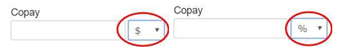

* **TIP #2**

**Clinic Daily Overview Report** – when collecting per diem calculated coinsurances, you must enter a % in the Copay field within Agile. Your Clinic Daily Overview Report will show you that a % needs to be collected on that patient, not a $ figure as previously existed. This way the % accurately tracks to a coinsurance collection, not a copay collection. Create a list of those per diem calculated insurances and keep them near the FO computer so anyone collecting from a patient is collecting the correct amounts. A tip on having those $ figures appear on the patients case (you have to go to the case regardless to post the payment) are listed below. Use your cheat sheet and place the following alert note on the patient’s case:

* 1. Add an Alert Note to Case Home Page under Account Notes
     1. Example: “Daily Co-Ins $10.60!”
* **Payment Arrangements** – while you have some leverage here, do know that we want to help our patient’s the best we can, but there are times when we cannot make an official payment arrangement. Self Pays – these are due at Time of Service. Work with your patients locally at the clinic. We cannot let Self Pay patient’s build up a bill, nor can they ever set up a payment arrangement with billing. It states in their paperwork that these payments are due at Time of Service; however, use your judgment when it comes to making in-house arrangements, knowing that those balances must not accumulate and must be paid in full at the clinic.

* **Canceling Appts** – Always mark cancel if not rescheduling. System will recognize if it is outside the 24-hour timeframe and indicate it as a VOID so it doesn’t count against your cancellation %. If you cancel within the 24-hour timeframe, it will count towards your cancellation percentage. If a patient has a block of future appts to cancel, you mark them as a Cancel and checkbox the statement that indicates “cancel all future appointments”. By doing this the future appointments will not count towards your cancellation percentage.
* **Merging cases w/existing patient MRN number (Medical Record Number)** – when onboarding a new-patient the FOC must do a search within Agile to identify if there is an existing patient within our system. The FOC must confirm that **all** data is identical prior to attaching a case to an existing MRN number. You must confirm every item of demographic information currently listed is **exact** before merging. All demographic information is shared across all cases and if it is removed, it clears it from all existing cases. The consequences of merging cases when it is not identical can be disastrous, which include skewing the POC of a patient for the clinician, statements sent to wrong patients, SSNs being saved and/or shared under the incorrect person, etc.
* **Reviewing Front Office Adjustments** – an FOC should be reviewing the REV-Adjustments Profile Report on a regular basis throughout the current month. This report will show you what adjustments are coming in and filtering through it to see which are Front Office Authorization and/or Visit Limit adjustments
* **Managing Red Alerts in Agile** – within a patient’s case you will occasionally see red boxes with a number within it. These are “alerts of items that are missing and need to be fixed”. Often-times you will hear me say “fix the red”, as this is what I am referencing. If you hover over the number within the patient’s case it will tell you exactly what is needed (i.e., Marketing source, Evaluation Date, Assignment of Benefits, Onset Date, Body region, etc., is missing). As you see them, fix them, as these items need to be fixed in order to complete an entire patient’s chart.  
    
  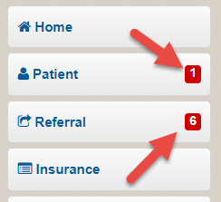
* **Patient Chart Audits** – the FOC needs to make sure that every patient has all uploaded administrative documents (all registration and billing documents) scanned into their chart. A new patient’s paperwork must be scanned and attached with all pertinent information pertaining to their case the same day as their evaluation.

**2020 CALENDAR YEAR VERIFICATION PROCESS**

**PARTNERS NOT CURRENTLY TRANSITIONED TO CIV**

* Reverification of insurance remains status quo – please follow your current process for the new Calendar Year

**CENTRAL INSURANCE VERIFICATION PROCESS**

* Reverification of same insurance(s) will ***only take place if there are changes to subscriber ID and/or group ID***. If all information is exactly the same, FOC needs to update coverage end date to 12/31/2020 in Agile along with documenting within the Insurance tab with the following message ***“Insurance remains same for CY 2020; date extension applied”***

* + - If a copay was removed from 2019 due to OOP & DED being met, FOC must reenter that copay into the copay field in Agile

* **If changes to insurance** à copy and scan card to patient’s chart à follow current process of verification of benefits

* **Auto/Work Comp/Liability Cases** –when building a case with any of these accident types, the “accident box” ***must*** be checked on the referral tab. Once checked, **2 dropdown boxes appear that must be completed (3 dropdown boxes if it’s an MVA/AUTO)**.  
    
  + ***Accident Type*** = choose either Work Comp, Auto or Liability

* + ***Accident Date*** = date the accident took place (ask patient and/or Nurse Case Manager/Adjustor)

* + ***State where Accident occurred (only if Auto selected)*** = State that the accident took place in (ask the patient, do NOT enter the Eval date)

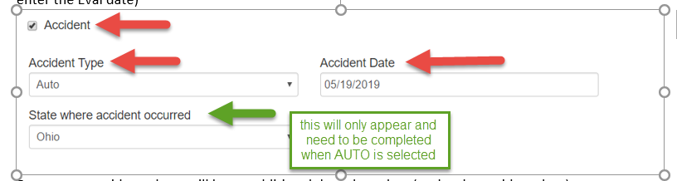

**\*\*Please Note: accident info must be included even if we are billing health insurance**

* **Updated Plan of Care/Progress Note (POC/PN) with MD Signature** – when you receive a signed PN/POC from the Physician, this serves as the most recent script for therapy and trumps the existing script. The date of the Rx that we use is the date the PN/POC was written by the treating therapist, not the date the physician signs it (example: POC created and signed by the treating clinician dated 11/28/2019, signed and returned from the Physician on 12/14/2019) The date of this effective script would be 11/28/2019.

**SELF PAY ACCOUNTS**

* Just a friendly reminder that all Self Pay payments are due at the time of service, prior to treatment. There are no exceptions. We cannot bill for services rendered after they take place. Having provided services prior to payment opens us up to not getting paid at all due to no photo id/insurance on file.

**PATIENT REFUNDS**

* If a patient is in need of a refund, FOC’s can submit a support ticket and attach the patient refund paperwork along with the ticket. The paperwork is located on the company Intranet. Also, we aren’t able to issue a refund until all of the DOS have been processed through the patient's insurance company.
* **Saturday evaluations – CIV** – for those partners on CIV and currently treating patients on Saturdays, please be sure to submit a helpscout ticket on Fridays for any scheduled Saturday evaluations.
* **Patient’s insurance change** – we need to ensure that when onboarding a patient and obtaining insurance(s) that we clarify that they have presented all insurance plans. In addition, we need to ask patients to inform us immediately should an insurance change take place, either adding, removing or changing a current insurance, we are made aware as soon as the change takes place to ensure proper billing and prevent insurance denials. It is best practice to always note a patient’s case with any information that pertains to the patient and our clinics. Documenting a quick note on the Home Page, **insurance change noted, is certainly feasible
* **Chart Audits** – all new patient charts need to be audited weekly in your clinic by the FOC. Any material that is missing should be scanned in and/or reaching out to the patient to obtain in order to build a solid and complete patient chart
* **Encounters on Hold** - This report will identify statements that you have put on hold, also Agile will automatically place a claim on hold if authorization is required but not yet added into the system. These claims then need to be manually released from hold after the authorization information is added. You will need to check to see if cases need to be released, otherwise claims will be denied due to not filing timely

* **Online patient paperwork not received in clinic shared email box** – we need to first ask the patient if they received a confirmation email after submission. If they did receive this email and you do not have it in your shared email box [FOCPartnerClinic@allianceptp.com](mailto:FOCPartnerClinic@allianceptp.com), please reach out to other clinics within your brand. Furthermore, you should be checking this email on a regular basis throughout the day and should you have another clinics paperwork in your email box, please make sure to contact that clinic to make them aware and forward it to them.
* **FOC & CD shared email** [**FOCPartnerClinic@allianceptp.com**](mailto:FOCPartnerClinic@allianceptp.com) – both the FOC as well as the CD should have this shared email visible and accessible to be checking for new patient requests, questions, paperwork, etc., on a regular and ongoing basis.

Please replace the New Patient Chart Audit form previously sent to you all earlier this week with the one above. The additional item that we have added to this audit is beneath the Insurance section. This would only apply to Traditional Medicare part B patients.

I have attached both the new chart audit form as well as a reference of the Secondary Payer form that is often missed, below.

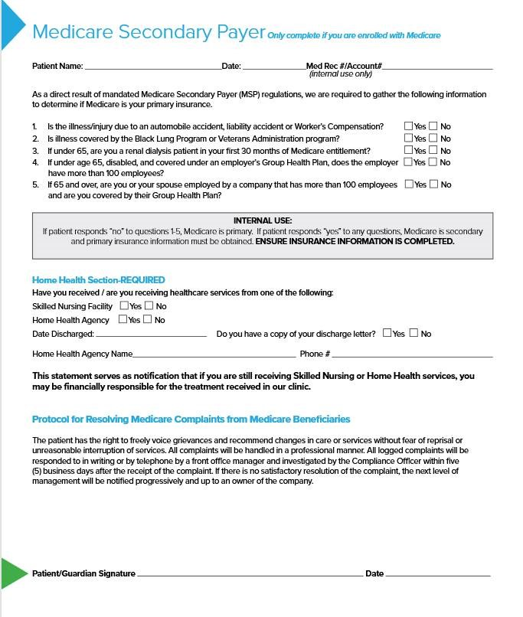

Please do not take out the insurance coverage when a patient goes from insurance to self-pay, or hit the patient pay button when they change to self-pay as it deletes the insurance. You should end the current policy, update the coverage and the add new coverage as patient pay.

Please see example below:

Example: Patient treated from 2019 to 2020. Policy ended on 12/31 and new one began with 60 visits for the year and new deductible and out of pocket amount. (see below patient becoming a self-pay)

Policy ending:

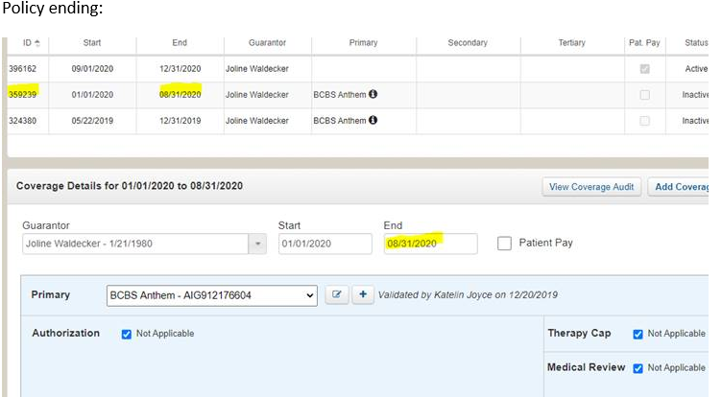

Patient becoming self-pay as of 09/01/20:

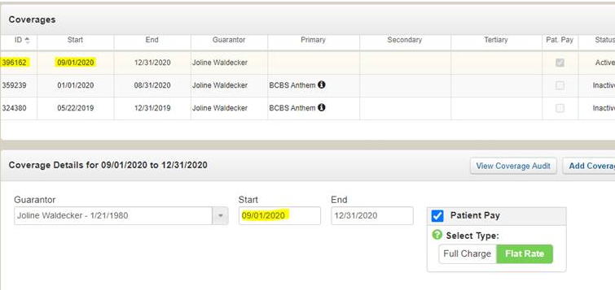

* If a credit card payment was received in another clinic and you are processing it remotely, you ***MUST*** post it as if you are sitting in that clinic. You must obtain the username/password for the clinic you are posting for and log in as that clinic (found in the shared folder). To complete the process after payment has been taken, you post in Agile as if you are sitting in that clinic, ensuring the location is accurate in Agile. The Day’s Deposits must accurately reflect the Location of the patient and the payment for that patient are in the same clinic.
* **CREDIT CARD ON FILE** – when posting a cc payment in Agile that is housed in CIM, please remember to choose ***“Card on File”*** vs credit card. When it comes time to reconcile for the month, it is far easier to identify credit card payments that are taken via a card at the desk as opposed to a stored credit card within our CIM system. In addition, when creating a profile for a patient in CIM, it is very important to identify by Clinic & Case # of patient (See below)
  + CIM – adding clinic/Case# in description field for reconciliation purposes
* **Telehealth/Home Care services** – providing gold standard care, an exceptional patient experience can take place at the date & time of a patient's choice. The same great service by one of our professional clinicians will be delivered in a positive, caring & respectful manner.
* **Covid-19 Patient Screening Form** – must be completed on every patient and staff member that enters our clinic. This includes temperature checks and the questionnaire completion followed by patient signature. These forms must be scanned into the patient’s Agile account each time they present in our clinics

As you know, the Intranet is a great resource for many things; forms, insurance guides and training materials to name a few. We care about your needs and your feedback is important to us. Please consider utilizing the fillable suggestion form (link below) should you have a suggestion; whether it be a:

* **Must have** – we are missing this functionality and it is essential for my job.
* **Should have** – we should consider adding this feature at some point. We are living without it currently but it would be very beneficial to create in the future.
* **Could have** – this a nice to have - we don’t need it but it would be helpful.
* **Trivial** – we can live without it but we wanted to just bring it to someone’s attention.

You can utilize the suggestion description box to add any addition comments or suggestions as well. Thank you for all you do. As always please share our tips with your Rehab Techs/Aides and anyone else you think may benefit. Our compiled list of tips are placed on the Intranet for reference.

<https://forms.office.com/Pages/ResponsePage.aspx?id=5-v1iUnDsUyNQbGh_0sgD2S2cUuZCsVMufcnekrnXBRUQUlIWDRZQ0hUT0ZFTkxKRkJFUkw0WVVENy4u>

Due to the fact this has come up a number of times recently and we have a number of new hires, I just wanted to review the fact that when we see Medicare patients we want to actually ask them if they have had any Home Care. If so we need to make sure that they have been discharged. Please explain to the patient that they need to double check as it is a process and if they have not been official discharged, services will not be covered. Explain that the entity that provided the Home Care for the patient has to update Medicare with the approved discharge date in order for PT to be covered. Once updated on the Medicare end, claims will process accordingly. We need to make sure that this is clear to the patient. This applies to Traditional Medicare plans.

The Intranet now has an updated Medial Records FAQ document and Authorization to Release form. These updated documents reflect changes to our program thus far. You can find them under documents- Compliance-Medical Records. Please discard all previous versions of these documents and begin using the updated version immediately.

A link is provided below for convenience. As always, please be sure to share these tips with your Rehab Techs/Aides and anyone else who handles the Front Office. Our compiled list of tips will be placed on the Intranet for reference.

[Medical Records](https://agilityhealth.sharepoint.com/:f:/s/AlliancePTPIntranetForms/Ev804-UZFSRMsm34KAC9lA4BKdoYKl0yMqI2vtK735lXEQ?e=n2PUKi)

* **Canceling Appts** – Always mark cancel if not rescheduling and elevate cancel calls to your clinicians before cancelling. Place detailed notes as to why the patient is cancelling. The system will recognize if the cancel is outside the 24-hour timeframe and indicate it as a VOID so it doesn’t count against your cancellation %. If you cancel within the 24-hour timeframe, it will count towards your cancellation percentage. If a patient has a block of future appts to cancel, you mark them as a Cancel and check the box statement that indicates “cancel all future appointments”. The future appointments will not count towards your cancellation percentage.

For example: I have an appointment today and I'm scheduled out for a few weeks. I want to cancel today and all future. Today's appointment would count as a cancel, but all others would not because they are outside of the 24 hour window and the box indicating “cancel all future appointments” was checked.

* **Deceased Patients** - In addition to placing the information in Agile, the FOC should send a Help Scout ticket to PST (Patient Services Team) for notification. This way if there is a patient balance, they can make the necessary adjustments and cease statements from generating.

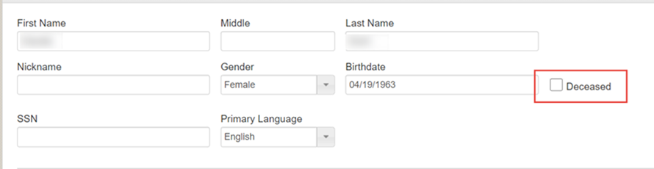

**Notate the patients account as well as indicate by placing a checkmark in the above box.

* **Medical Records** – updated protocols have been uploaded to our intranet for reference. Any requests be it a phone call, email, fax, etc., regarding records must be triaged through [medrecs@allianceptp.com](mailto:medrecs@allianceptp.com). No exceptions to this, please. Should a patient contact our Admin staff, we must be telling the caller that we correspond with this department via email only. Advise the caller should they need immediate attention to contact the Medical Records Department directly either via email [medrecs@allianceptp.com](mailto:medrecs@allianceptp.com), or phone 616-356-5024, fax 833-734-1183 with any status updates needed.
* **Patients Insurance Plans update – end of year – when to remove a copay** – please know that if a patient's insurance plan states their DED (Deductible) & OOP (Out of Pocket) has been met that most often, a copay that was previously due will no longer be due and can be removed from the Copay field in Agile. Before removing that copay, the FOC must confirm with the insurance that the copay is no longer due as well as document what has been met and why you are removing the copay from Agile on the Homepage, in Notes, of the patients account and remove the copay from the copay field.
* **CIM – Customer Information Manager (Credit Card Storage)** – all copays for the present day that are stored within CIM must be charged by the COB (close of business) that same business day by the FOC that was in the clinic at the time of patient’s arrival.
  + **CIM – Credit Card Storage** - *“We request that our patients provide a credit card on file that we will store on a secure server and assign an ID in place of all patient information to simplify the payment process for returning patients and recurring transactions. Your card being stored is in the event your insurance drops a balance to you as your responsibility. We will be in constant communication with you to keep you informed of any balances that begin accruing before processing any payments. If you should have a copay that is due at each visit, it is assumed that we can charge your card at the conclusion of your visit. What credit card would you like to place on file?”*

* **Returning Patients -** If a patient is returning for treatment it’s important to make sure we review their previous case in Agile and check to see if there is a balance on the case. Balances on previous cases must be addressed before moving forward with a new case. This ties in with following your discharge process. At the time of discharge, discuss/collect any balances on the case as well as any payment plan that may be necessary. Make sure you double check address, insurance information, DOB and document the discussion on the Home tab in Agile.
* **When managing cancel remember** to be conscious of offering our Telehealth program, we need everyone in the clinic to do their part in presenting the option of Telehealth to our patients. We in the Front Office are generally the first point of contact with our patients and can promote this option to them when those cancel calls come in. We should be working directly with every single patient who calls to cancel, this option should be offered and your clinicians should be involved on every call. We need to retain every possible visit we have available to us and not miss out on the opportunity to keep our patients on their POC.
* Overtime is prohibited unless approved by Kathy or Linda we all need to be conscious of our hours, which means we need to avoid all overtime as it is not approved. Be cognizant of your timesheet and discuss with your CD if your scheduled hours need to be readjusted.
* **You can now choose case type for Auto, WC and Liens** under the case tab. Once you make your choice please remember to hit the save icon. Utilizing this function ensures the proper reports are generated for our teams in regards to tracking. It’s also a convenient way to see what type of case the patient might have from the case home page rather than having to dig for the information. Please note, by now everyone is aware that Marissa is onboarding all of our Agile Virtual Care patients so Front Office will not need to utilize that option as Marissa will. Thank you!

* 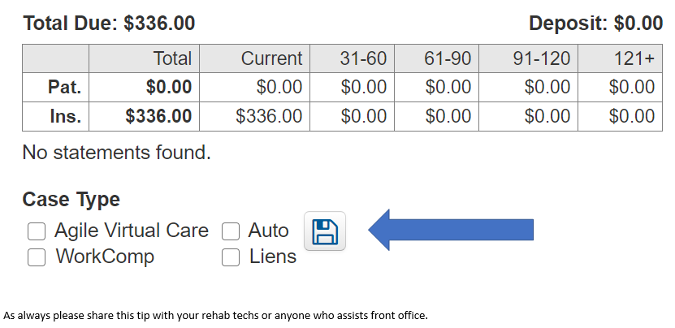**Discharging Patients.** By now everyone should be following the Discharge Procedure in place; ensuring we confirm that addresses remain the same as when patients started therapy, payer information, insurance, etc. remains as were quoted and adjust if necessary. Also, documenting any conversation of what took place on the Home page of the patient’s case in Agile. As a tip moving forward, when you run your Case Inactivity Report on Tuesday, if you identify a patient that has been discharged by their physician or has self-discharged (be sure to notify your clinician), we can have the discussion over the phone, confirm all information is correct, collect any balance and document the conversation on the Home tab in Agile.

* **1099 Forms – 2020** – should your clinic receive a 1099 form sent to your clinic, please be sure to forward these on to Mike Laponsie, Director of Treasury – [Mike.Laponsie@allianceptp.com](mailto:Mike.Laponsie@allianceptp.com)

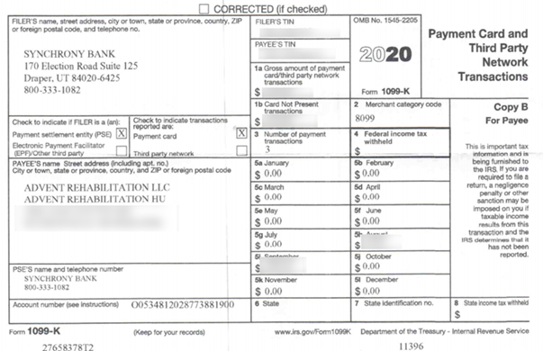

* **Online Fillable Paperwork** – This key strategy for improving our onboarding and intake process not only improves the patient registration experience, but it is also instrumental in contributing to timely appointments and displays a well-organized practice. Directing patients to our websites and/or sending the patient a link to the online & fillable paperwork in an email should be our method of choice for all patients.
* **Insurance Checks received in Clinic** – should never be deposited at the clinic level. Any and all insurance checks received in the clinics should be mailed directly to your LOCKBOX.
* **Patient Visit Outlook -** As you know we always want to ensure our patients are scheduled out according to their POC. Every Monday we are to run our Patient Visit Outlook report in order to identify patients that need to be scheduled. When running this report, you can use the sort option and run the report from “Least to Most” This will help you to identity and work the most pressing cases first.

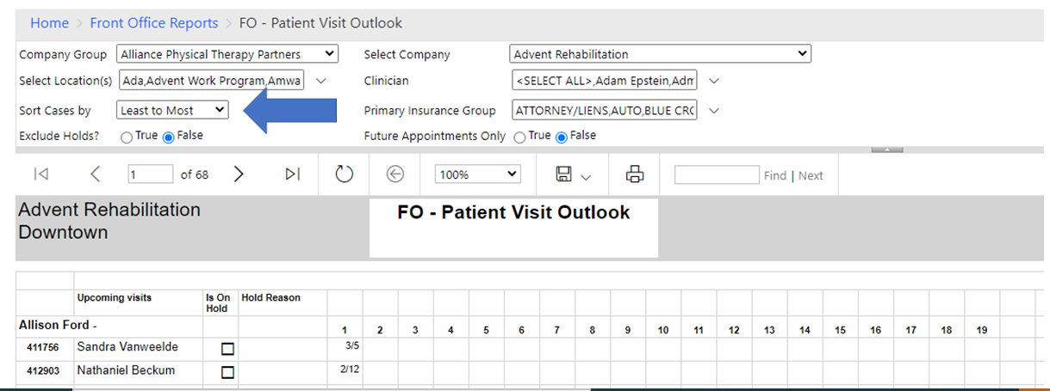

* **Adding physician to AgileRPM**

In order to cut down on duplicate entries and errors, the process for adding physician information into the system has changed. If an FOC identifies that a doctor needs to be added to AgileRPM, please submit a helpscout ticket to that affect and our team will add all pertinent information accordingly. Please note, current FOC accesses have been removed.

* **Accident check box**

This week’s tip serves as a reminder to slow down and ensure we include all necessary information on our cases when creating them. Often-times we have claims that are rejected due to misspelled names, or if we do not provide all the necessary information. We’ve had an uptick in cases where the accident box is not checked on the referral tab in Agile. This needs to be checked so that it prompts patients claims to be billed with the appropriate information. It is required when we are billing auto cases.

Although weekly chart audits are required, consider auditing new patient charts at the end of each day. This will help to ensure all the necessary information is in place and correct so that claims are not denied and are processed correctly. Thanks Team and make it a great Wednesday!

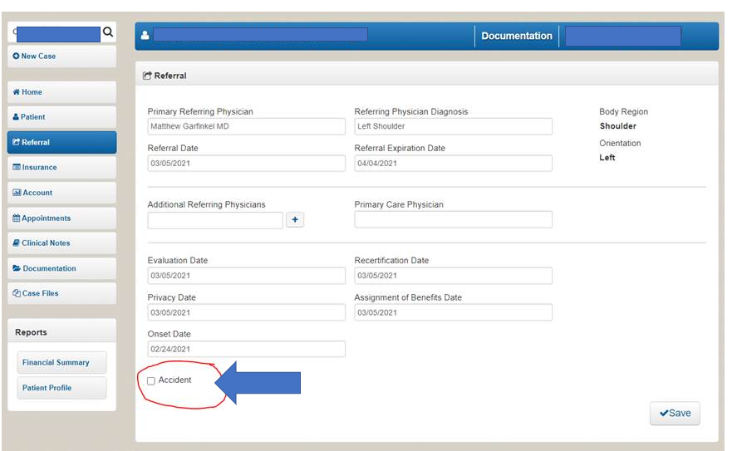

* **Cashless Clinics** – at the conclusion of 2020, we had transitioned all brands/clinics within the Alliance organization to cashless. We determined this together and deemed it be the safest for our patients, clinics and staff.
* **FCE New Patient Paperwork** – new patient paperwork should NOT be sent via email or provided to patients ahead of their FCE appointment due to it being part of their evaluation. The patient has a sitting tolerance portion of the exam and this is an opportune time to have patient’s complete this in its entirety.
* **Over the Counter Credit Card & Check payments** – if someone takes a payment in your clinic such as the Rehab Aide and/or Clinician, ensure that they have the proper login methods when running that payment. The CIM login should ONLY be used if a patient has a credit card ON FILE. If the patient is presenting a payment over the counter to them, they are to use the merchant log in (Clinic login). In order to ensure payments were taken properly and posted accurately, you need to balance your finances the following business morning ensuring the appropriate method was chosen when posting to Agile (CIM payment = Card on File / Credit Card = card swiped through the cc terminal)
* **Work Comp Nurse Case Manager/Adjustor (NCM/ADJ)** – every WC patient will have an Adjustor (ADJ) and most, but not all, will have a Nurse Case Manager (NCM). This information is crucial to obtain along with a telephone & fax number and be logged into Agile. This information must be noted on the Referral Tab / Notes section of every WC Case.

* **Accident Detail entered in Agile** - Accident detail of the patient must be listed on the referral tab in Agile. Accident type and date of injury are required on all auto and work comp cases (See below). In addition, for your quick reference, the Case Type should be checked on the Home screen as well (see below)

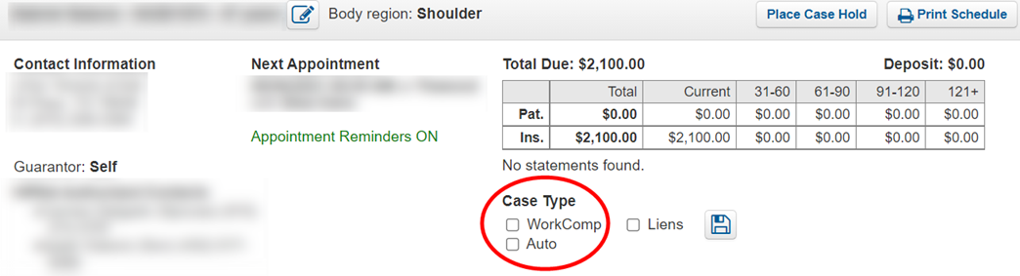

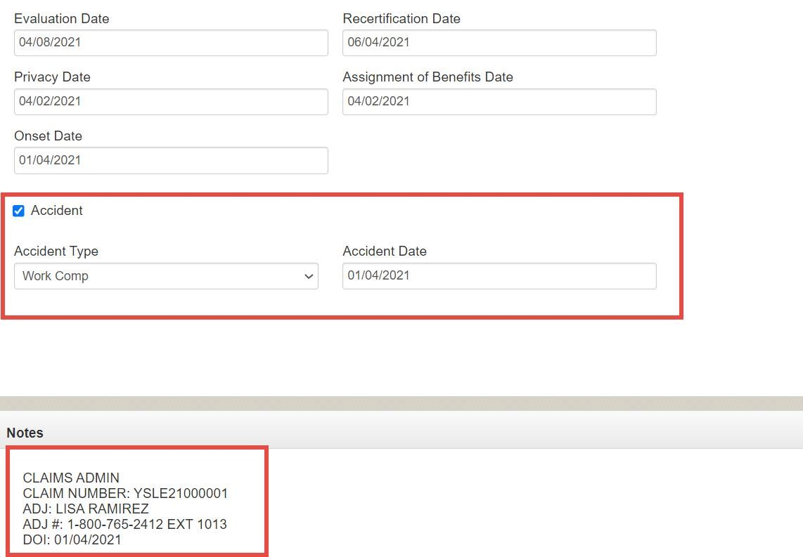

* **Demographic documentation/Insurance documentation** - the patient's name on the case **MUST** match the patient’s insurance card. This is particularly important for claims reimbursement as well as for some insurances that require us to submit medical records. If a patient has gotten married and the name on the insurance card does not match the name on the case, documentation submitted to the insurance will appear as 2 separate individuals.
* **Weekly Chart Audits** – chart audits of all new patients need to be completed on a weekly basis. Once the chart audit is completed, scan and file in the new patient’s case as follows: Case files > Miscellaneous > “Chart Audit”. The audit form is attached as well as placed on our intranet > Front Office Operations > Important Documents & Forms > All Practices > New Patient Chart Audit
* **WellCare and NIA authorization process** – effective July 1st any patient presenting with WellCare insurance requiring Physical and/or Occupational authorization must be obtained through NIA (National Imaging Associates). All WellCare training/education materials are posted on the NIA website, [www.RadMD.com](http://www.radmd.com/) If you are a new user, you must create a RadMD account ID and password by logging into this website, click “New User”, select “Physical Medicine Practitioner” and submit a “RadMD Application for New Account”. You will be issued a password link via email once completed and be asked to create a new password. Additional links for additional training and education will be on the options menu once logging into their website.
* **Posting credit card/CIM credit card payments** - PLEASE make sure that you are entering the Authorization number and **NOT** the last four digits of the credit card number in the “CC Auth/Check #” field in Agile.
* **Collecting and Posting payments in Agile** - We should **always** be posting payments for the ***DATE PAYMENT WAS RECEIVED***, not the DOS the patient was treated. If you have a patient paying today for last Friday’s DOS, you post it using TODAY’S date – the actual date you took the money. You can always place a side note in the notes section that it was for a specific DOS; but that is not necessary. It is very important to post money the date it was received in order to reconcile efficiently on the back end.
* **Online New Patient Paperwork/Consents needed** – if a patient is ready to begin his appointment and paperwork is not entirely received, we must have the patient sign a Consent to Treat as well as HIPAA prior to the patient being taken back into the gym and treated by a therapist. In order to keep the flow of appointments on time in the clinic, providing this to the patient in order to be treated must be done as we continue to research the whereabouts of their paperwork. Should the patient’s paperwork not be received, the patient can complete the necessary paperwork at the completion of his appointment; however, these 2 consents must be signed before heading into the gym.
* **PATIENT PAYS A COLLECTION BALANCE IN CLINIC** – If an Active or Discharged patient pays in clinic for a balance on their account, we must be documenting clearly within the notes tab of that patient’s case. Place a detailed note in the “Notes” section on the Home Page as well as sending an email to Holly Yonker in our Patient Services Team would be needed so that Holly could contact the Collection Agency (if it has gone to Collections) to inform of the payment received.
* **Insurance Card(s)** – When scanning a patient’s insurance card (s) it is very important that we scan both the front and the back of the insurance cards into the patient’s case. Verification of phone numbers and claims mailing addresses are extremely important for both verification/confirming benefits as well as claims submissions.
* **Money on Deposit** - a patient that wishes to use money on deposit from a previous case, a Help Scout ticket should be submitted to RCD requesting the patient funds be transferred to the most recent case. If warranted, RCD will perform the transfer. This will allow patient funds to apply automatically to any balances incurred on the active patient case.
* **Authorization Number / Check** – when a credit card is taken for payment in the Front Office, a unique “Authorization” number is provided and must be identified in the “Check/Auth #” field.
* Do ***NOT*** use the last 4 digits of a patient’s credit card number as substitute for this authorization number is insufficient as well as a hazard for the Finance team to reconcile.

* **CIM credit card payments** – when posting credit card payments these transactions must be posted **THE DAY THE PAYMENT IS TAKEN**. If you are not in the clinic and a patient was treated yesterday but you are processing the payment today, you need to post the payment today. You can make a note in the payment transaction for the DOS the payment is applied to.
* **Auto/Work Comp/Liability Cases** – when building a case with any of these accident types, the “accident box” must be checked on the referral tab. Once checked, 2 dropdown boxes appear that must be completed (3 dropdown boxes if it’s an MVA/AUTO).
* **Cashless Clinics** – at the conclusion of 2020, we had transitioned all brands/clinics within the Alliance organization to cashless. We determined this together and deemed it be the safest for our patients, clinics, and staff. Every clinic must have the “cashless clinic” sign posted in your clinic.
* **Work comp**-We should be asking every new patient when they call to set up their evaluation, or if we call them from a referral “is the reason for your therapy related to a work comp claim or an auto accident?” Is so, we need the following information is the note section of the insurance tab:

NCM/Adj/Third party payer (IE Medrisk)

Phone numbers

Claim number

Date range & number of visits authorized

* **Chart Audits** – Each FOC needs to complete a new patient chart audit weekly on all new patient charts. Checking for any missing information and/or correcting information entered incorrectly. Ensure the patient’s name, DOB, address (including apt # if applicable), etc. are all correct. We must make sure we have a complete and accurate chart and have everything scanned in.
* **HIPAA Privacy Contact information** – many adult children (18+) remain on their parent’s insurance policy as well as reside in the same residence. Please know that due to HIPAA, if a patient is 18+ years of age, they must disclose a HIPAA approved contact to discuss their account or personal information with anyone, including their parents.
* **INSURANCE CHANGES** – if an insurance change is warranted at any time during a patient’s episode of care, we ***never want to replace*** the existing insurance currently built within the case. You must “end date” the existing insurance by placing the last day of coverage in this field. You will then need to “Add Coverage”, entering the start date the insurance begins and end date it at 12/31/xxxx.
* **Copy Patient Information** – this button ***must*** be pressed when entering patient information from their insurance policy on the insurance tab. Clicking this “Copy Patient Information” button automatically pulls patient information verbatim to how it was entered in the patient tab. There is no need to retype this information. An example of this button is reflected below within the Insurance Policy “Insured Name” section.

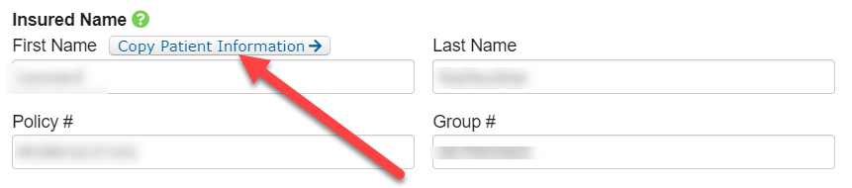

* **Self-Pay Patients** – all self-pay patients must sign a Self-Pay form indicating responsibility and understanding of payment due at time of service.
* **CREDENTIAL MY DOC** - Please continue to utilize CredentailMyDoc for all your insurance needs as it pertains to our insurance providers. Our Credentialing Department maintains this tool, making updates to each Partner in real time that reflects into AgileEMR. Questions on insurance information listed within CredentialMyDoc or within Agile EMR regarding the status of an insurance should send their inquiries to [credentialing@allianceptp.com](mailto:credentialing@allianceptp.com).
* **Morning balancing**-Before closing your day, you need to log into Auth.net and run the settlement report for “reports” within Auth.net for that prior day’s date. Compare EVERY transaction against whey you have posted and entered as “card on file”. In addition, you must be checking off every receipt from a credit card you swiped the day before against your Detail report in Agile the next morning. Ensure you remember to add “invoice number” and clinic name in the invoice description field. Verifying this information will make for a smooth close of day and month.
* **POSTING PATIENT OTC MONIES COLLECTED IN THE CLINIC**
  + **Cash/Check** = use the date when payment was received., i.e., patient’s cash/check was collected on 04/21/22 should be posted to 04/21/22
  + **CIM/CC payment** = use date when CIM/CC was charged., i.e., CIM/patient’s CC payment was performed on 04/21/22 should be posted to the date of 04/21/22. In short, running/charging CIM and CCs payments need to be posted on the date the CIM/CC was charged.
  + **Note**: **if the FOC is charging the CIM/CC payment today for a past DOS, the FOC would use today’s date to post within AgileEMR**.
* **Patient Chart Audits** - The following documents ***MUST*** be included, some of which must be signed & scanned into every patient chart.
* **Patient Information** (new patient packet) – includes all demographics & insurance information
* **Consent to Treat** – this must be signed by every patient ***PRIOR*** to being treated by a Clinician – no exception
* **HIPAA**
* **Patient Health Questionnaire**
* **Photo ID**
* **Insurance Card(s)**
* **Prescription for Therapy (if needed)**

* + **Patient Chart Audits** – the FOC needs to make sure that every patient has all uploaded administrative documents (all registration and billing documents) scanned into their chart. A new patient’s paperwork must be scanned and attached with all pertinent information pertaining to their case the same day as their evaluation. In addition, proof of the patient’s paperwork against the intake documentation received must match to accurately build a patient’s chart. Weekly Chart audits need to be performed by the FOC by reviewing all New Evals on a weekly basis.
* **Department of Labor** - DOL insured work comp patients can be scheduled and treated if they have an open and allowed claim and a referral from the MD. We can retro authorize to the date of Eval if the FOC cannot immediately get access to the portal.
* **Online new patient paperwork-** When you receive the email with a patient’s online new patient paperwork we need to click on the hyperlink at the bottom of the email. It will look like this:

Patient Signature:  
 [https://urldefense.proofpoint.com/v2/url?u=https- 3A__alliancephysicaltherapypartners.tfaforms.net_esignatures_record_20530008-2D8465-2D4fec-2Dbfbc-2Dac527b08715d-3F-5Ft-3D3-26access-3D860d00065655785580b14b2304395f0903494d7efdb003d476b093a06444e609&d=DwIFaQ&c=euGZstcaTDllvimEN8b7jXrwqOf-v5A_CdpgnVfiiMM&r=QXsseSvE85vU6XoB0mHQTKMAV-DozwYykJvircCkLUAILkUyiTLTIVXd-](https://urldefense.proofpoint.com/v2/url?u=https-3A__alliancephysicaltherapypartners.tfaforms.net_esignatures_record_20530008-2D8465-2D4fec-2Dbfbc-2Dac527b08715d-3F-5Ft-3D3-26access-3D860d00065655785580b14b2304395f0903494d7efdb003d476b093a06444e609&d=DwIFaQ&c=euGZstcaTDllvimEN8b7jXrwqOf-v5A_CdpgnVfiiMM&r=QXsseSvE85vU6XoB0mHQTKMAV-DozwYykJvircCkLUAILkUyiTLTIVXd-8y_oO7Y&m=cqS5aWiT7F3me7Ynco_LhUviKI6H1IVglFD1jltbGNI&s=qhWW76Zwt36KlyXVpMXECT1r0UOC4IDYm9g4Gu5lUao&e=)

I have taken part of this patient’s link out so we are not violating HIPPA. After you clink on that link you will be able to see the actual signature for the patient. You will then need to right click and hit print. The print screen page will appear, change the destination to “ Save as a PDF” and upload that into Agile for the new patient packet. This will allow for the signature and e-signature to be viewed within the patient’s chart. If the patient did not sign or e-sign the consent form, they will need to sign a paper copy in clinic.

* **Agile EMR Referral Tab / Accident Information** – collecting and documenting a WC patient’s Adjuster and/or Nurse Case Manager’s information and contact phone numbers is now available and must be included in the collection of a WC patient’s chart. All WC patients will have an Adjuster, but not all will have a Nurse Case Manager. We should be asking for both upon intake and documenting those folks in the Referral Tab as indicated below.

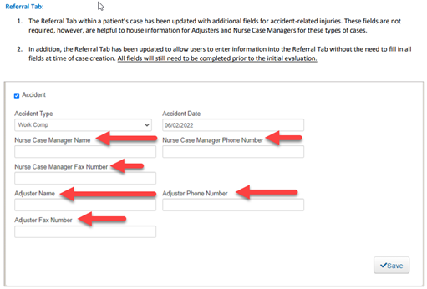

* **Documenting benefit explanation to patients at time of evaluation** – the FOC (or whoever is checking in the new patient for their evaluation) is expected to be relaying every new patient their explanation of benefits by quoting the benefit verification that is placed within the insurance tab of the patient’s chart by our Central Insurance Verification (CIV) department. An explanation of coinsurance, deductibles, copays & visit maxes should be explained in a precise manner to the patient to provide them a general idea of what their insurance company will cover and what the patient’s responsibility will be. We too should always be encouraging our patients to verify their own benefits to confirm the quote we have provided them is accurate. Once that is completed, a note must be placed within the insurance tab “Notes” of that patient’s chart indicating the following comment ***“Benefits explained to the patient as CIV has indicated above”.*** This statement is then saved and will be time and date stamped that an explanation has been provided to the patient.
* **Red Envelope Policy –** to enable our employees to cooperate with authorities quickly & compliantly should they arrive onsite to perform an investigation, inquiry, or inspection. The Red Envelope should be placed in a conspicuous place in the Front Office of the clinic to allow access by staff members. Within this envelope is the protocol intro letter and protocol to adequately comply with these requests.
* **MVA Personal Injury Intake Form** – This 2-part intake form will guide you and the patient in understanding and collecting all financial responsibility should they present with an Auto/MVA accident and/or Personal Injury. This form needs to be completed, acknowledged, and signed by the patient so they clearly understand how we will bill for this treatment based on the selections they have indicated and understanding their responsibility for any potential out of pocket expenses. This form is then scanned into Case Files within the patient’s chart.
* **Work Comp – Employer Information** – all Work Comp patients were injured on the job, and we need to be asking for that employer’s name. Some patients no longer work at that employer, so it is our duty to ask the patient the name of the employer of where they were injured. This information gets input into the employer field on the patient tab in Agile.
* **Online Paperwork** – when onboarding a new patient, it is best practice to always encourage our patients to complete the online paperwork as well as upload all insurance card(s) and their photo ID. The ***only*** time we do not want a patient to complete the paperwork in advance is when they are scheduled for an FCE (Functional Capacity Evaluation) as completion of that paperwork must be done in the clinic as it is part of their exam testing.